**Corner rustic wooden shelf**

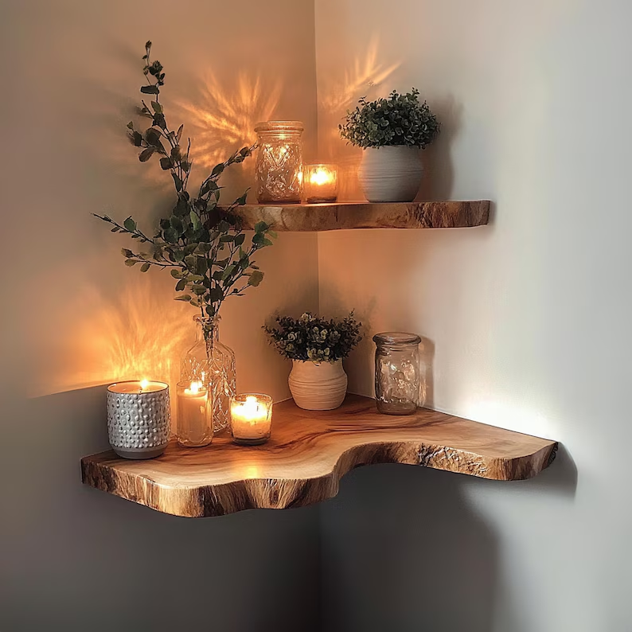A Corner Rustic Wooden Shelf is a charming and functional piece of furniture that brings warmth and character to any room. Typically made from reclaimed or distressed wood, this shelf embraces a vintage or farmhouse-inspired aesthetic, making it perfect for adding rustic charm to your living room, bedroom, kitchen, or hallway. The design utilizes corner spaces efficiently, providing a great spot for displaying plants, photos, books, or décor. With its sturdy construction and natural wood grain, a corner rustic wooden shelf offers both style and practicality, making it an ideal addition to any home looking to enhance its rustic appeal.

.